- Group the current “Upload EOB” and “Dashboard” together under a folder called “873 files”
- Create a new folder named “277 files” that contains “Upload file” and “Dashboard”
- “Upload File”
  - We must be able to upload 100s of files at the same time via drag and drop or using selections from local folders
  - When a file is uploaded, first thing that happens is we fetch the “NPI” and try to match this task to an agency we have under “Agencies”
  - If no “Agency” with the same NPI is found then you will give the following error
  - 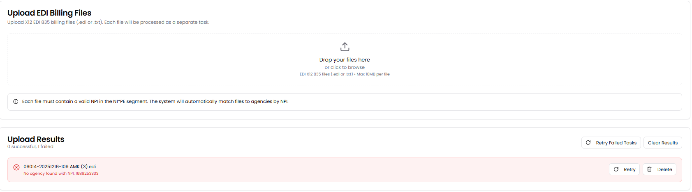 The user may retry or delete afterwards.
  - Only if an agency with the corresponding NPI is found after the retry or the initial upload, we will create a task under “Dashboard” with the same layout, functionality (including the file viewing and downloading) and options as shown below. However, you may remove the Total Amounts, Status, RA Date, Remarks, and Retries columns. In the filters you may remove the “Status”. Retry and delete functionalities are needed for each task. If a tas is deleted, the files associated with it will forever be removed.
  - 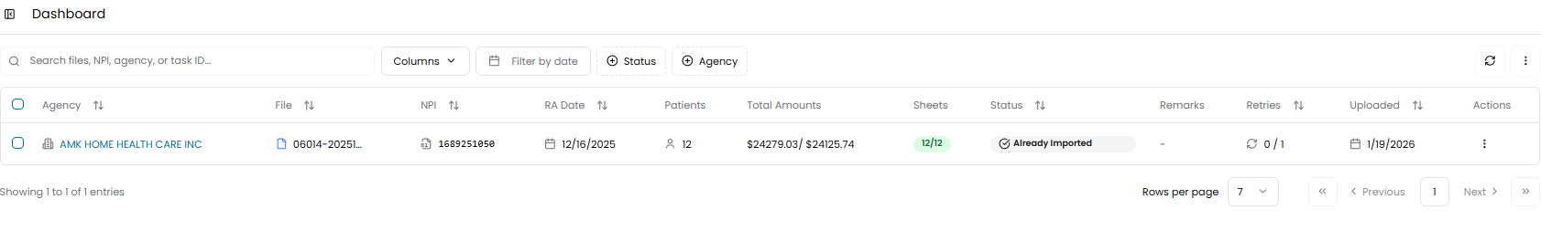
  - Once the task is created, we are going to parse the text file using the following values. Once they are parsed, in the dashboard, we will show how many patients there were in the file. After parsing, using google sheets API we will input the values into the correct columns (as seen in image below).
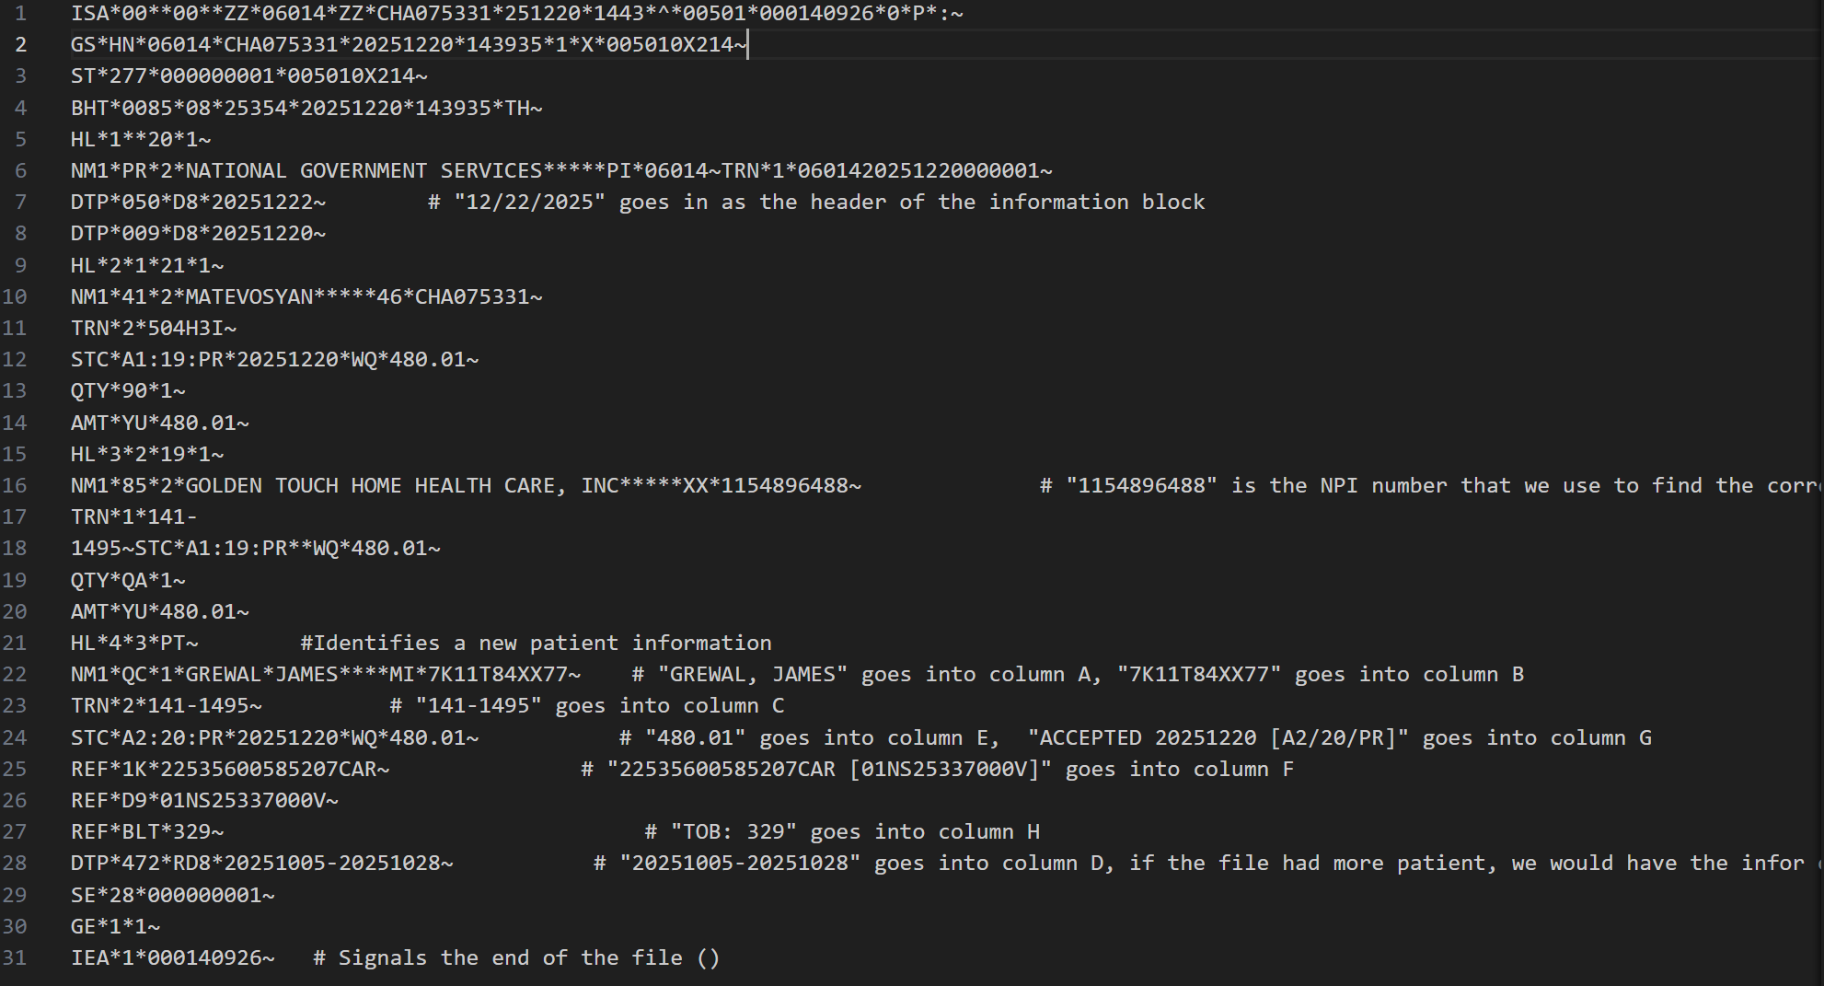
  - Before inputting the values, you must locate the correct google sheet by matching the NPI extracted from that file to the NPI in the sheet’s title. If there is no match, then the task will fail with the error of “No spreadsheet found with NPI [1111111111]”.. When a task fails because sheet wa snot found, under column sheets in “Dashboard”, we will have 0/12 or 0/5 (depending on what the number of patients were) and it will turn red. When you hover over it, we will see the error of “No spreadsheet found with NPI [1111111111].
  - Once it locates the correct sheet, we will first have to read the spreadsheet and understand where the last entered line was. We will then skip a row, put the date (shown in the image under point g) in column A, skip one more row and start entering the values.
  - Once the entire input is carried out, we will update the sheets to show green and 12/12 or 5/5 or 3/3 depending on how many patients were input.
  - Keep in mind the google sheets API limits because these limits right now are 300 read and 300 write requests per minute. You will need to use exponential backoff and batch orders together to not exceed these limits. Exponential backoff should be for a maximum of 128 seconds with 7 retries starting from 1 second.

NOTE:

For Parsing, you may use the following resources, they will make it easier in my opinion. These include Python libraries for parsing and parser interpreter if you need it. See below:

X12 EDI and 837/835 Viewer and Converter | Healthcare Data Insight
pyx12 · PyPI
azoner/pyx12: HIPAA X12 document validator and converter
imsweb/x12-parser: A Java parser for ANSI ASC X12 documents.
copyleftdev/x12-edi-tools: A comprehensive set of tools for working with X12 EDI files

